

American International University-Bangladesh (AIUB)

**Department of Computer Science**

**Faculty of Science & Technology (FST)**

**Research Methodology**

**Assignment**

Submitted By

|  |  |  |  |  |  |
| --- | --- | --- | --- | --- | --- |
| **Semester: Summer_2023-2024 FINAL TERM** | | | | **Section: F** | **Group No: 05** |
| SL | SN | Student Name | Student ID | Individual  Contribution (100%) | Total Marks: 40 |
| Earned Marks: |
| **A** | 01 | NUSRAT JAHAN NOOR | 21-44550-1 | 20% |  |
| **B** | 21 | LAMIA ISLAM | 22-46627-1 | 27% |  |
| **C** | 28 | MD. ASHIKUZZAMAN ABIR | 22-47006-1 | 27% |  |
| **D** | 29 | A.F.M. RAFIUL HASSAN | 22-47048-1 | 26% |  |

Submission Date: 19-09-2024

**The assignment will be Evaluated for the following Course Outcomes**

|  |  |
| --- | --- |
| CO1: *Evaluate* all relevant resources for designing a computer science and engineering solution and determine the level of novelty of the research. | Total Marks (9) |
|  |
| **Problem Analysis and use of State-of-the-Art** **Resources:** Discuss the research problem background with best use of state‐of‐art literature, resources, and technologies to produce a significant result that is likely to have a major impact. | [3 Marks] **A: B: C: D:** |
| **Critical Reflection and Creativity in Research Objective:** Deep insight demonstrated and presented a creative solution to the real‐life problem. And Results are critically confronted with various existing literature | [3 Marks] **A: B: C: D:** |
| **Novelty and Contribution of the Research:** Elaborately discuss and identify the contribution of the research to the development of scientific concepts by recognizing the research gaps of existing research and developments. | [3 Marks] **A: B: C: D:** |

|  |  |
| --- | --- |
| CO2: *Analyze* the collected data to provide valid solution of the research problem acknowledging the limitations. | Total Marks (9) |
|  |
| **Data Analysis:** Elaborately discuss the research method, its appropriateness and details on data collection, analysis, and synthesis for proposing valid solution to the research problem. | [3 Marks]  **A: B: C: D:** |
| **Solution and Validation:** Elaborately discuss the solution of the research problem by establish a direct connection between proposed solutions with the research objective based on the collected research data. | [3 Marks]  **A: B: C: D:** |
| **Limitation and Scope of Future Studies:** Elaborately discuss abstract and concluding remarks of the research with its limitations and scope of future studies. | [3 Marks]  **A: B:  C: D:** |

|  |  |
| --- | --- |
| CO3: Determine and Demonstrate professional codes of ethics and standard in conducting research considering public safety; the impacts of engineering activity; economic, social, cultural, environmental and sustainability. | Total Marks (9) |
|  |
| **Free of Plagiarism, Data Falsification Citations and References:** Submit plagiarism free research paper (similarity index is <10%). In-text citations and reference list citations were complete and properly formatted in APA or any other standard style. The Research data is not fabricated or altered intentionally to fit into the predetermined research findings. Materials are properly cited and referenced if they are taken from other sources. And not attributed to a source from which it has not been obtained *(i.e., false citation)* | [3 Marks]  **A: B: C: D:** |
| **Professional codes of ethics and standard:** The research elaborately demonstrates professional codes of ethics and standard in conducting research considering public safety; the impacts of engineering activity; economic, social, cultural, environmental and sustainability. | [3 Marks]  **A: B: C: D:** |
| **Formatting and Submission:** Submitted in due time, the report is complete and there are no errors in spelling, format, and grammar. Consistently  presents a logical and effective organization. | [3 Marks]  **A: B: C: D:** |

|  |  |
| --- | --- |
| CO4: *Defend* the research solutions based on complex engineering activities by delivering an effective presentation to the audience. | Total Marks (9) |
|  |
| **Presentation delivery (eye contact and body language):** Keeps eye contact with audience all the time, use natural gestures and movements, looks confident. | [3 Marks]  **A: B: C: D:** |
| **Enthusiasm/Audience Awareness:** Demonstrate strong enthusiasm about the topic, significantly increases audience understanding and knowledge of the topic, convinces an audience to recognize the validity and importance of the subject. | [3 Marks]  **A: B: C: D:** |
| **Creativity and Use of Media:** The presentation was creative in design and effectively use multimedia. | [3 Marks]  **A: B: C: D:** |

|  |  |
| --- | --- |
| Viva/Defense | Total Marks (4) |
| Defend the research in performance in the question/answer session. | **A: B: C: D:** |

**Analyzing the Influence of Urban Heat Island Phenomena on Energy Consumption Dynamics of the Major Bangladeshi City Dhaka – A Statistical Approach**

Md. Ashikuzzaman Abir, A.F.M. Rafiul Hassan, Lamia Islam, Nusrat Jahan Noor

Department of Computer Science

American International University-Bangladesh

Corresponding author: 22-47006-1@student.aiub.edu

**ABSTRACT**

This paper investigates the consequence of Urban Heat Island phenomena on the Energy demand in Dhaka. Time Series Analysis, Linear and Polynomial Regression analysis and Correlation analysis were conducted to investigate the connections between temperature and energy demands by using several data from three different reliable sources. These analyses identified a strong connection between temperature and energy demand with correlation coefficient 0.83 and reflect the trends in the recent years. These findings are helpful for urban planners, policymakers, and energy authorities to take necessary actions to mitigate the heat island affects such as developing building materials that could be able to minimize heat absorption, promoting green infrastructure instead of destroying or building energy savior components.

**Keywords:** UHI, Temperature, BPDB, Regression, Correlation.

**INTRODUCTION**

The Urban Heat Island (UHI) effect, caused by human activities and infrastructure, causes elevated temperatures in urban areas like Dhaka (Tasneem Tariq et al. 2020). Energy consumption practices are influenced by this effect, that gets harsher by urbanization and the reduction of green space, particularly in tropical regions like Dhaka. Bangladesh is projected to be over 56% industrialized by 2050, according to UN urbanization forecasts. Thus, it is crucial to comprehend how UHI acceleration and demand for energy interplay for the deployment of sustainable energy.

**Problem Background:**

In recent years, the temperatures in Dhaka have soared, with the city experiencing its hottest day in 58 years in April 2023, when the temperature hit 40.2°C (The Daily Star-April 15,2023). This substantial increase in temperature highlights the growing effect that heatwaves, which become worse by factors like urban heat island effects, are having on the region.

Urban Heat Islands (UHIs) are elevated temperatures in urban areas, causing significant energy demand, especially for cooling. According to Tasneem Tariq et al. (2022), Dhaka, a major city in Bangladesh, observes UHI intensities of up to 7.5°C, which imposes burden on urban infrastructure and represents a barrier to sustainable development. The considerable strain this increase in usage of energy imposes on urban infrastructure renders attempts to achieve sustainable development in these rapidly urbanizing areas significantly more challenging. Bangladesh is predicted to become 56% urban by 2050; hence it is crucial to address the influence of UHIs on the sustainability of energy. With a focus on seasonal energy demands, this research aims to investigate the association between UHI intensity and energy usage in Dhaka.

**Related Studies:**

Several studies on the UHI consequences in tropical cities have revealed associations between surface temperature rise, vegetation loss, and urbanization. UHI increases temperatures throughout the day and decreases overnight cooling, which elevates the possibility of a variety of sicknesses, including physical discomfort, respiratory issues, exhaustion, heatstroke, and heat-related mortality (Tan et al. 2010). According to data from the Population Reference Bureau, 3.4 billion people, or 50% of the worldwide population, inhabit urban areas (Talha Hassan et al. 2021). In Dhaka, the impact of Urban Heat Island (UHI) is marked by fluctuations in temperature between 2.5°C and 7.5°C (Tasneem Tariq et al. 2022). The phenomenon defined as the "Urban Heat Island" (UHI) effect happens when temperatures in urban areas are significantly greater than in surrounding rural areas due to altered surface temperatures and human activities (Qian et al. 2022). In Dhaka, a 1°C fall in air temperature leads to an approximate 81 MW reduction in power consumption (Arif Istiaque et al. 2018). The peak daily UHI intensity is 2.15°C, with a mean of 0.48°C (Adiba Tabassum et al. 2024). The Dhaka Metropolitan Area is defined as an urban heat island since heat events influence almost 87% of it (Rakin Abrar et al. 2022).

Surprisingly very little research has been performed, especially regarding the way Dhaka's urban heat island (UHI) influences the consumption of energy. Furthermore, while several types of studies have investigated UHI and energy patterns within Bangladesh's the core cities, they are lacking in recent information, especially since 2021. The present investigation addresses this gap by using the most recent information (2021–2024) from different sources to perform an extensive statistical evaluation that corresponds alongside our research goal.

**Research objectives:**

The main targets of this study are to investigate the connection between energy consumption and urban heat island (UHI) intensity in the major Bangladeshi city Dhaka throughout various seasons, in addition to the temporal variations in UHI effects and their impact on cooling energy demand over the past decades. To accomplish these goals, the study will investigate two main research questions: In Dhaka city, how does the intensity of the UHI affect energy use? Moreover, how closely do trends in energy consumption and fluctuations in temperature triggered by UHI correlate?

**Research Contributions:**

In an overall societal context, this research aims to support advancements towards more sustainable urban environments, helping urban areas, specifically in Dhaka cope with climate change while reducing energy costs and enhancing public health and comfort. By providing data-driven analyses of how UHI effects influence energy demand, energy suppliers can use the findings to more accurately forecast future energy demand patterns, facilitating infrastructure development and effective resource allocation. Urban planners, policymakers, and energy authorities in Bangladesh will benefit significantly from this research by learning about trends in temperature increases and energy consumption, which will help urban planners design strategies for mitigating heat island effects, such as developing building materials to minimize heat absorption.

**METHODOLOGY**

This investigation includes the use of statistical analysis using secondary data that was accumulated between January 2021 and June 2024 from a variety of trustworthy sources. The objective of the analysis is to evaluate how Dhaka's energy consumption and urban heat island (UHI) impacts relate to each other.

**Data Collection:**

The Bangladesh Power Development Board (BPDB) contributed the energy consumption data for Dhaka in a daily basis, and daily records were merged to figure out monthly consumption. The worldwide meteorological database “Weather and Climate” contributed the temperature data, that was then enhanced with comprehensive data from the Bangladesh Bureau of Statistics (BBS) Statistical Yearbook of Bangladesh. The foundation for analyzing the association between UHI intensity and energy usage is established by the above data sets.

**Procedure:**

* To identify patterns in fluctuations in temperature and consumption of energy from 2021 to the present, a time series analysis was conducted. Patterns were found utilizing monthly data from 2021, since data on energy use was meticulously combined from daily values.
* The relationship between energy consumption and temperature was investigated employing both polynomial and linear regression techniques.

According to Ramjeet et al. (2022), the model for linear regression was used,

s = β1d + β0

In this instance, d represents temperature as the independent variable and s for the consumption of energy as the dependent variable. The slope and intercept are symbolized by the values β1 and β0, respectively.

According to Eva Ostertagova et al. (2017), the formula for polynomial regression was,

yi = β0+ β1xi+ β2xi2+ β3xi3+….+ βkxik+ *ei* , for i = 1, 2, …., n

where the degree of the polynomial utilized for fitting the data is denoted by the letter k.

* To figure out the pattern and magnitude of the relationship among temperatures and energy consumption, correlation analysis eventually was performed. This comprehensive approach enables it feasible to execute an extensive investigation of how Dhaka's energy usage patterns are influenced by UHI intensity.

**RESULTS AND ANALYSIS**

**Research results:**

The time series analysis of electricity load demand from 2021 to 2024 reveals distinct seasonal patterns and an upward trend over the years (Figure 1 & 3). The load demand fluctuates significantly across the period, with regular peaks and troughs, suggesting seasonal influences, such as increased electricity use in certain months.

The time series analysis of temperature data from 2021 to 2024 highlights clear seasonal fluctuations, accompanied by a noticeable long-term warming trend (Figure 2). After an initial period of relatively stable demand, the trend starts to rise.

The linear regression analysis reveals a significant positive correlation between temperature and electricity load demand (Figure 4). The intercept of approximately 30,648 MW indicates a substantial baseline electricity demand even at 0°C, suggesting that a large portion of electricity usage is independent of temperature.

The polynomial regression analysis using a degree 2 model shows that approximately 70.4% of the variance in electricity load demand can be explained by temperature changes, with an R-squared value of 0.704 (Figure 5). The quadratic nature of the relationship is highlighted by the coefficients, where the linear term is negative (-4,499.59), and the quadratic term is positive (160.16), suggesting a U-shaped curve.

The correlation analysis between electricity load demand (MWh) and temperature reveals a strong positive relationship, with a correlation coefficient of 0.83 (Figure 6). This indicates that as temperatures increase, electricity demand also rises, likely due to higher energy usage for cooling systems during warmer months.

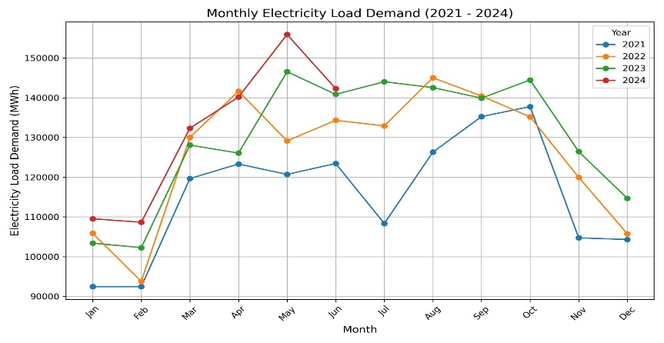

**Figure 1:** Electricity load demand over time **Figure 2:** Temperature data over time

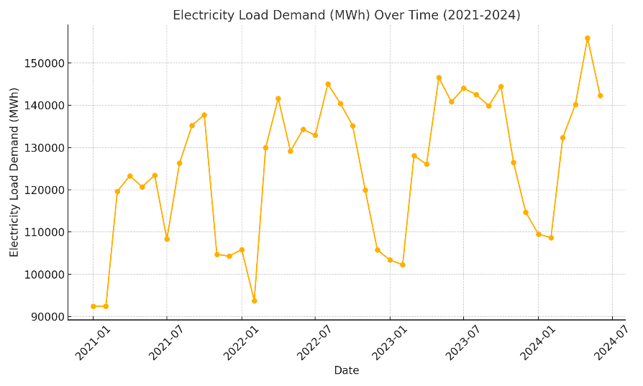

**Figure 3:** Electricity demand over time **Figure 4:** Linear Regression

**Figure 5:** Polynomial Regression **Figure 6:** Correlation Analysis

**Analysis and Discussion:**

A time series analysis of temperature and energy consumption from 2021 to 2024 has been employed to assess the research questions. Verifying the findings, the study applied polynomial and linear regression models to demonstrate an extensive relationship between temperature and energy usage, with fluctuations in temperature representing 70.4% of the fluctuation in demands for energy. The results are consistent with previous studies, notably Tasneem Tariq et al.'s (2022) investigation, which revealed substantial UHI effects in Dhaka. In addition, the conceptual consistency of the outcomes is verified by the mathematical equations used to perform the correlation analysis.

**RQ1:** How does the intensity of the UHI affect energy use?

* The degree of severity of UHI significantly increases energy demand.

**RQ1:** How closely do trends in energy consumption and fluctuations in temperature triggered by UHI correlate?

* Use of energy has gradually elevated in response to elevated temperatures, with noticeable seasonal differences in the warmer months.

**CONCLUSION**

The aim of this study is to understand the relationship between rising temperatures and electrical power needs through investigating the implications of the Urban Heat Island (UHI) phenomena on energy consumption in Dhaka. Through regression modeling, the study's evaluation of data encompassing 2021 to 2024 represented 70.4% of the variance in energy consumption and using correlation analysis identified a strong positive connection (0.83). The outcomes exhibit how UHI has a major impact on increasing consumption of energy, particularly in warmer months, and highlight the need of strategies such as utilizing green infrastructure and heat-resistant building materials. Still, limitations include the utilization of a polynomial regression model, dependency on secondary data, and a focus to a particular location. For a more comprehensive understanding of UHI influences on energy consumption, subsequent research could deal with these by utilizing advanced modeling approaches, expanding to multiple regions, and which includes primary data.

**REFERENCES**

Anon, M. F. (in press). Dhaka experiences 'hottest day in 58 years'. The Daily Star.

Statistical Yearbook of Bangladesh, Bangladesh Bureau of Statistics, Statistics and Informatics Division, Ministry of Planning, Government of the People’s Republic of Bangladesh, Dhaka, Bangladesh.

Bangladesh Power Development Board (BPDB). Available at https://misc.bpdb.gov.bd/area-wise-demand.

Weather and Climate. Available at https://www.weatherandclimate.eu/history/41923.

Yadav, R. S. (2022). A Study of Relationship to Absentees and Score Using Machine Learning Method: A Case Study of Linear Regression Analysis. IARS’ International Research Journal, 12(1), 33–39.

Ostertagová, E. (2012). Modelling using Polynomial Regression. *Procedia Engineering*, *48*, 500–506.

Tariq, T. (2020). Urban Heat Island Phenomena in Dhaka, Bangladesh. In ARCC-EAAE 2022 INTERNATIONAL CONFERENCE, Miami, USA.

Tan, J., Zheng, Y., Tang, X., Guo, C., Li, L., Song, G., Zhen, X., Yuan, D., Kalkstein, A. J., Li, F., & Chen, H. (2009). The urban heat island and its impact on heat waves and human health in Shanghai. International Journal of Biometeorology, 54(1), 75–84.

Istiaque, A., & Khan, S. I. (2018). Impact of Ambient Temperature on Electricity Demand of Dhaka City of Bangladesh. Energy and Power Engineering, 10(07), 319–331.

Abrar, R., Sarkar, S. K., Nishtha, K. T., Talukdar, S., Shahfahad, Rahman, A., Islam, A. R. M. T., & Mosavi, A. (2022). Assessing the Spatial Mapping of Heat Vulnerability under Urban Heat Island (UHI) Effect in the Dhaka Metropolitan Area. *Sustainability*, *14*(9), 4945.

Hassan, T., Zhang, J., Prodhan, F. A., Pangali Sharma, T. P., & Bashir, B. (2021). Surface Urban Heat Islands Dynamics in Response to LULC and Vegetation across South Asia (2000–2019). Remote Sensing, 13(16), 3177.

Tabassum, A., Park, K., Jaemyeong Mango Seo, Han, J.-Y., & Baik, J.-J. (2024). Characteristics of the Urban Heat Island in Dhaka, Bangladesh, and Its Interaction with Heat Waves. Asia-Pacific Journal of Atmospheric Sciences.